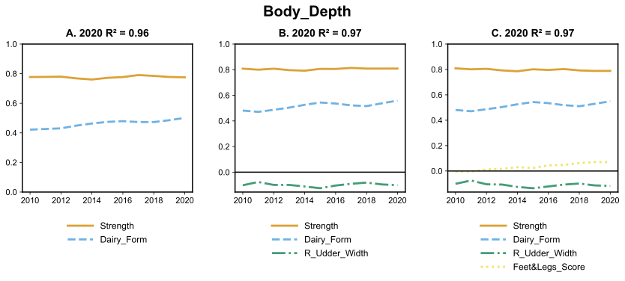Figure S1: Coefficients of 2 (A), 3 (B) and 4(C) factor regression on Body Depth over time with corresponding R² based on year 2020.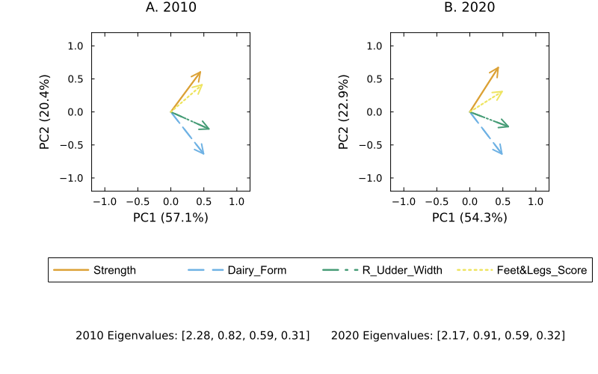Figure S2. Principal component analysis biplots for the 4-factor regression for Body Depth in 2010 and 2020.
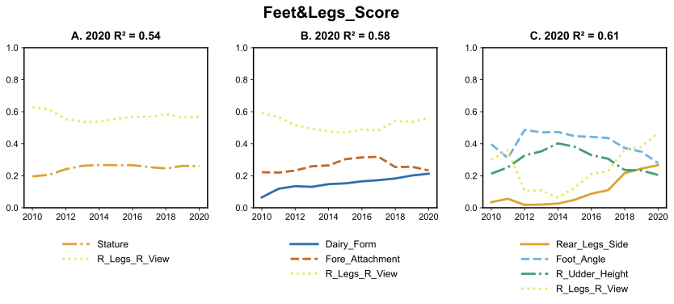Figure S3: Coefficients of 2 (A), 3 (B) and 4(C) factor regression on Foot and Legs Score over time with corresponding R² based on year 2020.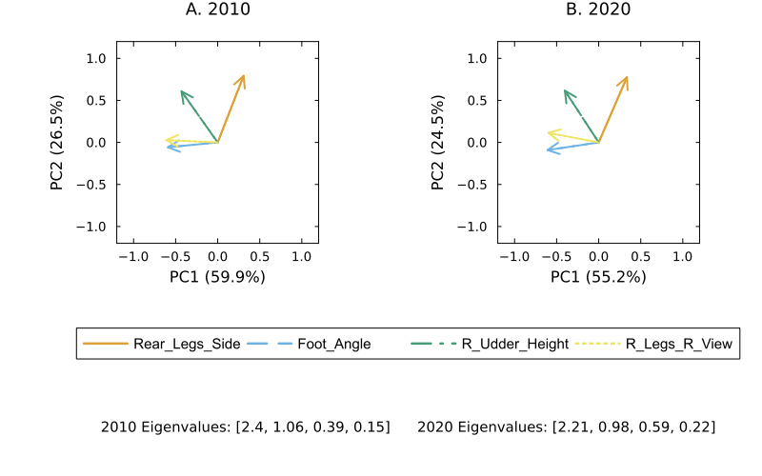Figure S4. Principal component analysis biplots for the 4-factor regression for Foot and Legs Score in 2010 and 2020.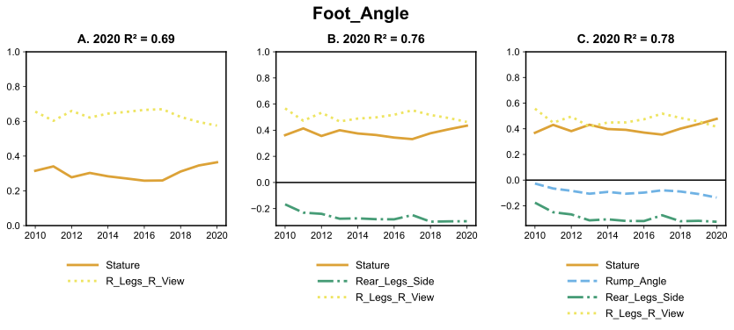Figure S5: Coefficients of 2 (A), 3 (B) and 4(C) factor regression on Foot Angle over time with corresponding R² based on year 2020.
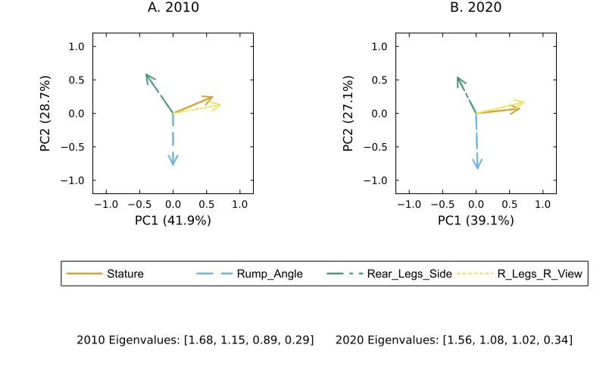Figure S6: Principal component analysis biplots for the 4-factor regression for Foot Angle in 2010 and 2020.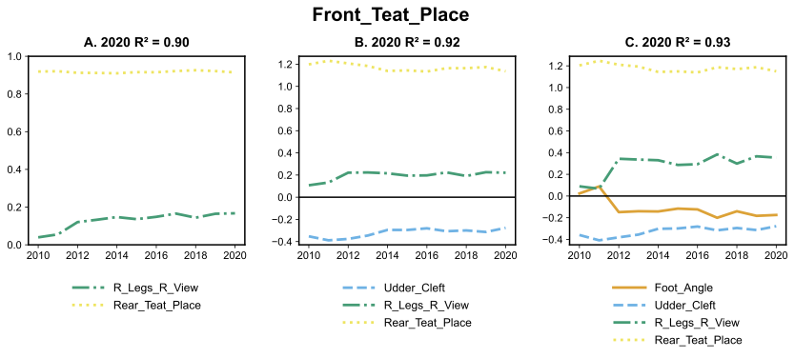Figure S7: Coefficients of 2 (A), 3 (B) and 4(C) factor regression on Front Teat Placement over time with corresponding R² based on year 2020.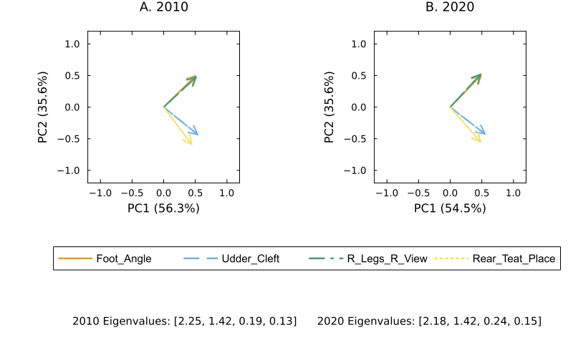 Figure S8. Principal component analysis biplots for the 4-factor regression for Front Teat Placement in 2010 and 2020.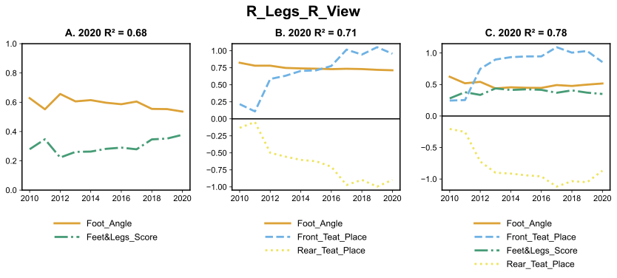 Figure S9: Coefficients of 2 (A), 3 (B) and 4(C) factor regression on Rear Legs Rear View over time with corresponding R² based on year 2020.
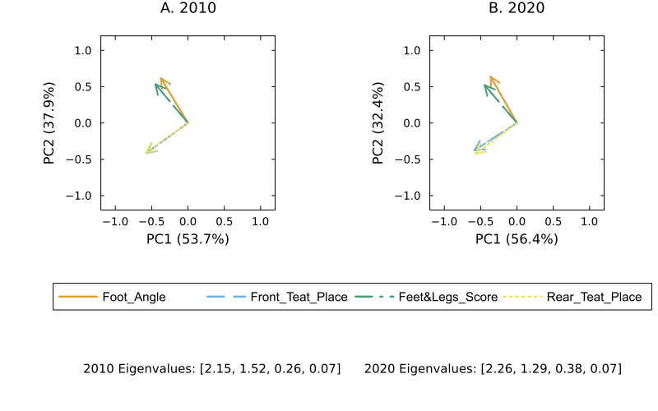 Figure S10. Principal component analysis biplots for the 4-factor regression for Rear Legs Rear View in 2010 and 2020.
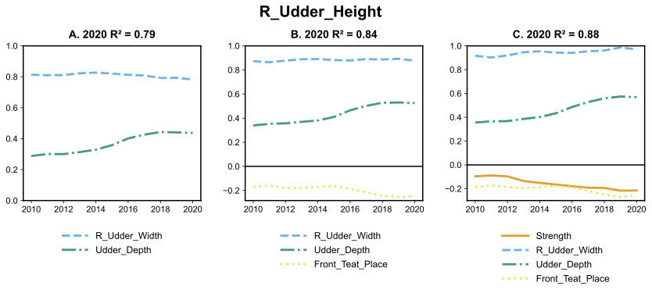 Figure S11: Coefficients of 2 (A), 3 (B) and 4(C) factor regression on Rear Udder Height over time with corresponding R² based on year 2020.
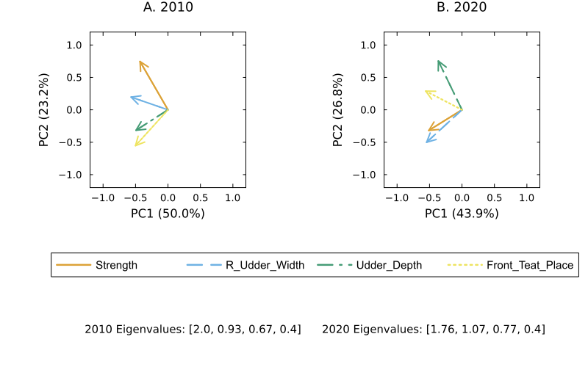 Figure S12. Principal component analysis biplots for the 4-factor regression for Rear Udder Height in 2010 and 2020.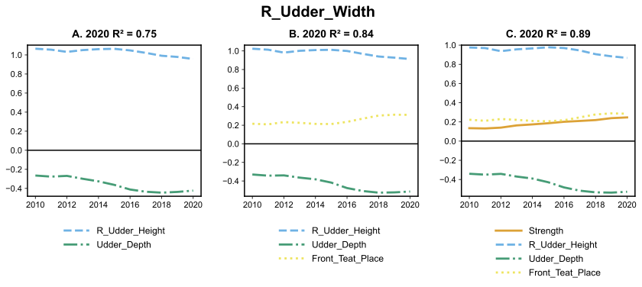 Figure S13: Coefficients of 2 (A), 3 (B) and 4(C) factor regression on Rear Udder Width over time with corresponding R² based on year 2020.
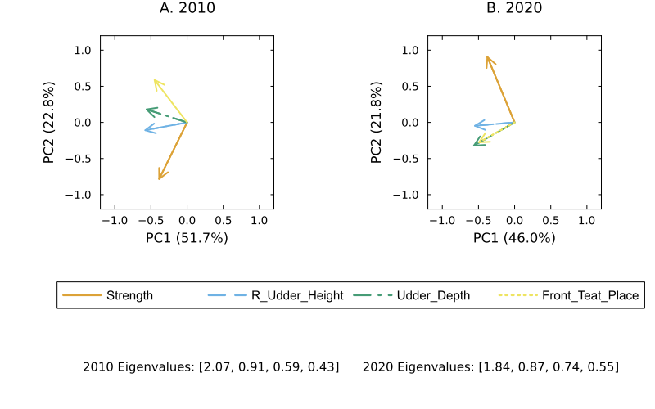Figure S14. Principal component analysis biplots for the 4-factor regression for Rear Udder Width in 2010 and 2020.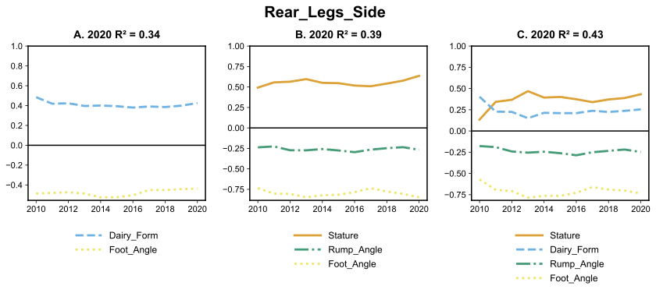 Figure S15: Coefficients of 2 (A), 3 (B) and 4(C) factor regression on Rear Legs Side View over time with corresponding R² based on year 2020.
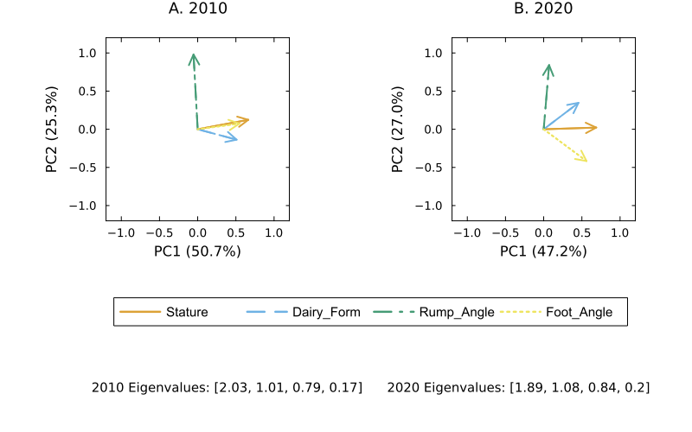Figure S16. Principal component analysis biplots for the 4-factor regression for Rear Legs Side View in 2010 and 2020.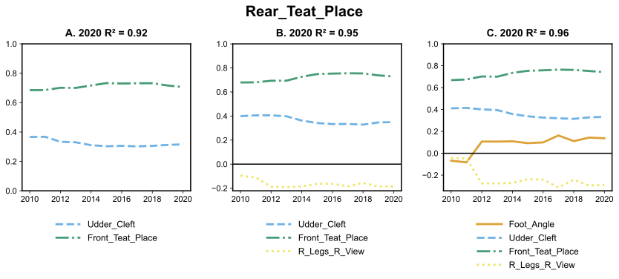 Figure S17: Coefficients of 2 (A), 3 (B) and 4(C) factor regression on Rear Teat Placement over time with corresponding R² based on year 2020.
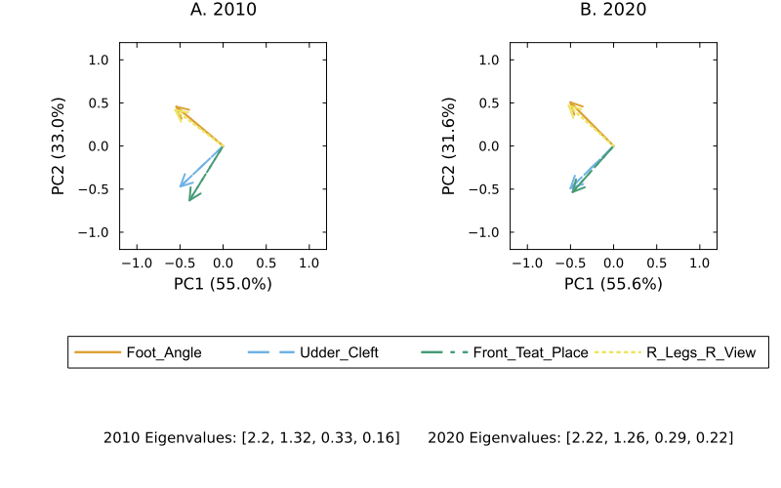 Figure S18. Principal component analysis biplots for the 4-factor regression for Rear Teat Placement in 2010 and 2020.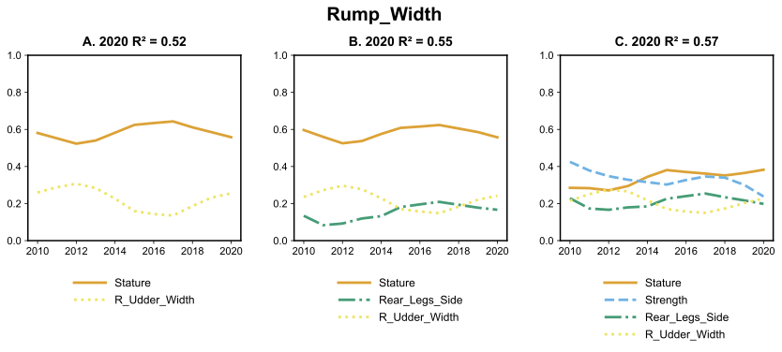 Figure S19: Coefficients of 2 (A), 3 (B) and 4(C) factor regression on Rump Width over time with corresponding R² based on year 2020.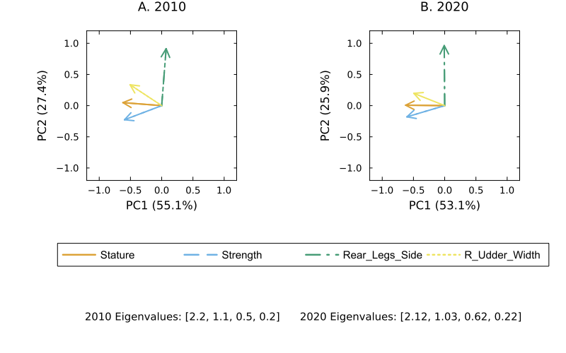 Figure S20. Principal component analysis biplots for the 4-factor regression for Rump Width in 2010 and 2020.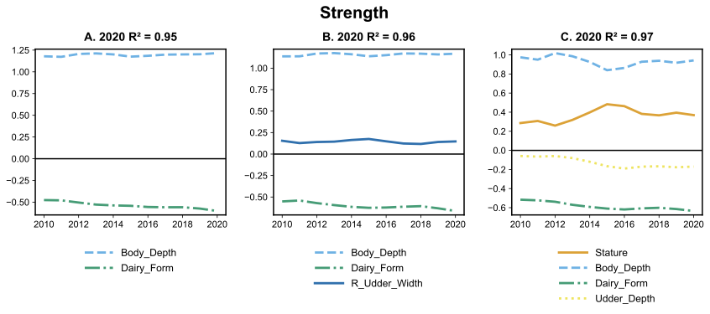 Figure S21: Coefficients of 2 (A), 3 (B) and 4(C) factor regression on Strength over time with corresponding R² based on year 2020.
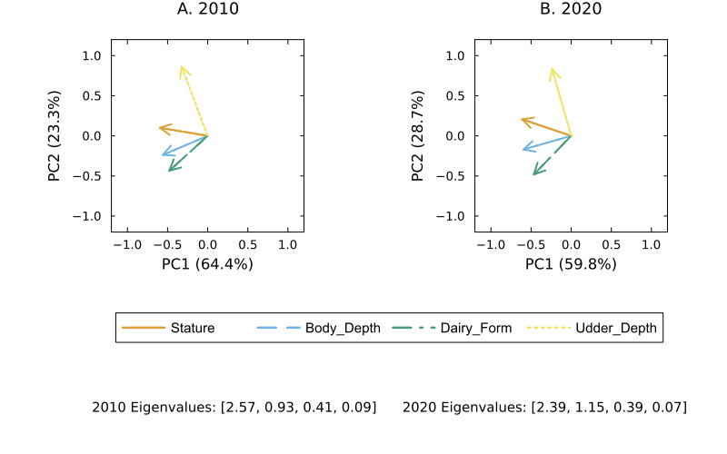 Figure S22. Principal component analysis biplots for the 4-factor regression for Strength in 2010 and 2020.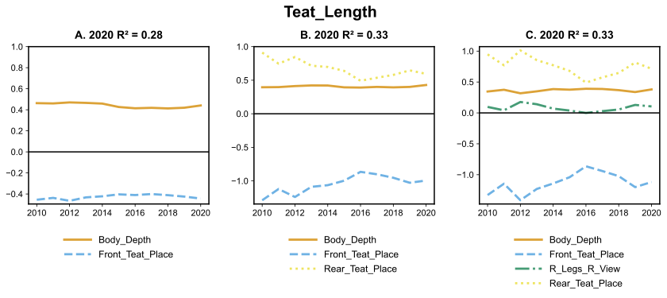 Figure S23: Coefficients of 2 (A), 3 (B) and 4(C) factor regression on Teat Length over time with corresponding R² based on year 2020.
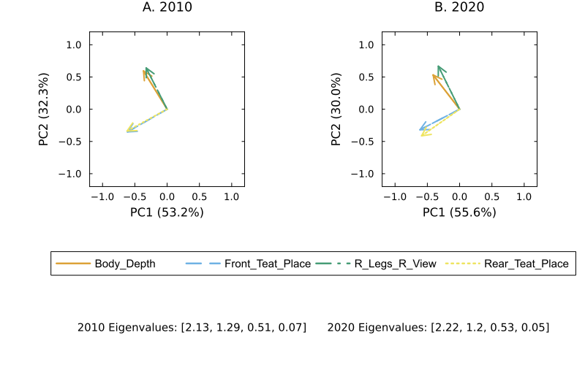
Figure S24. Principal component analysis biplots for the 4-factor regression for Teat Length in 2010 and 2020.
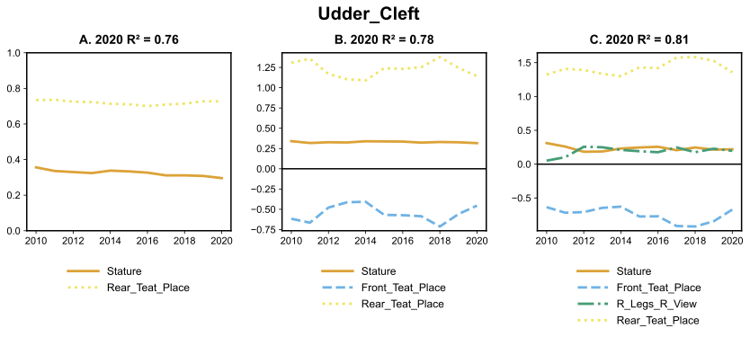 Figure S25: Coefficients of 2 (A), 3 (B) and 4(C) factor regression on Udder Cleft over time with corresponding R² based on year 2020.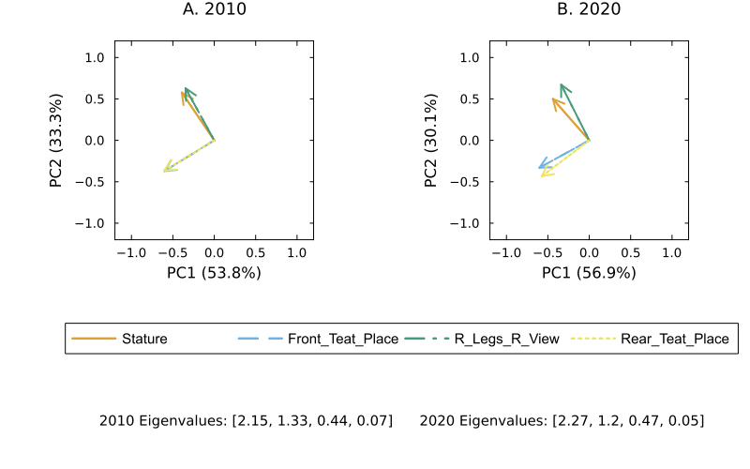
Figure S26. Principal component analysis biplots for the 4-factor regression for Stature in 2010 and 2020.
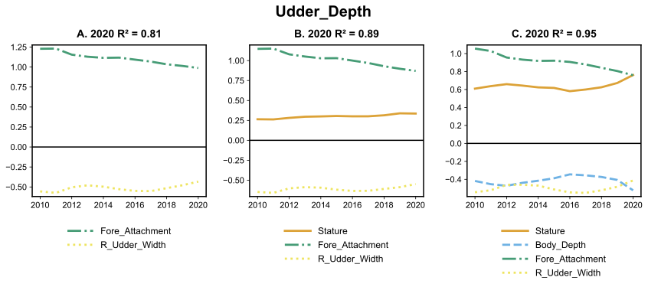 Figure S27: Coefficients of 2 (A), 3 (B) and 4(C) factor regression on Udder Depth over time with corresponding R² based on year 2020.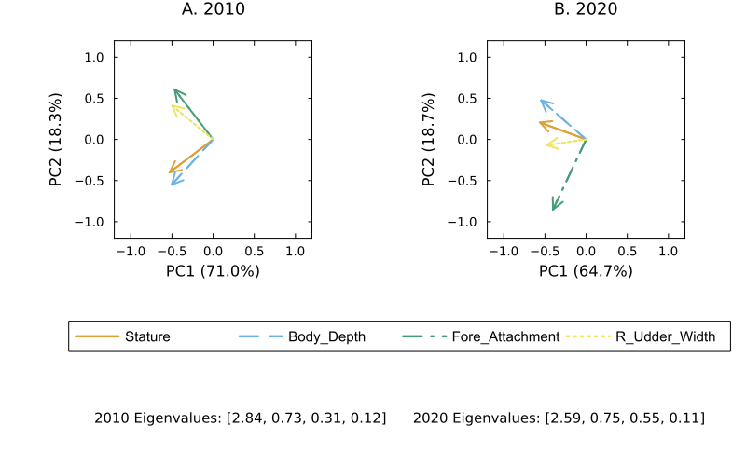 Figure S28. Principal component analysis biplots for the 4-factor regression for Udder Depth in

